ROYAL BRIDGE
HIGH SCHOOL

#301-1123 Westwood St
Coquitlam BC V3B 0M3
604.474.3718
Your Pathway to Excellence

STAFF HANDBOOK

2020-2021

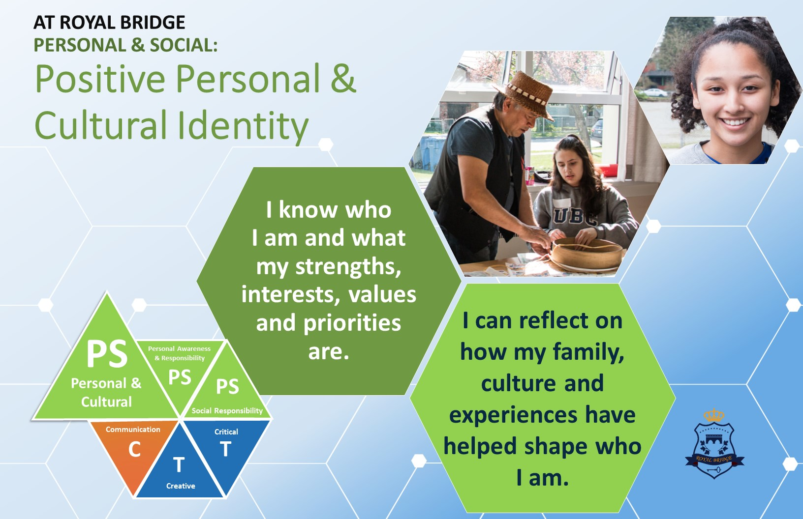

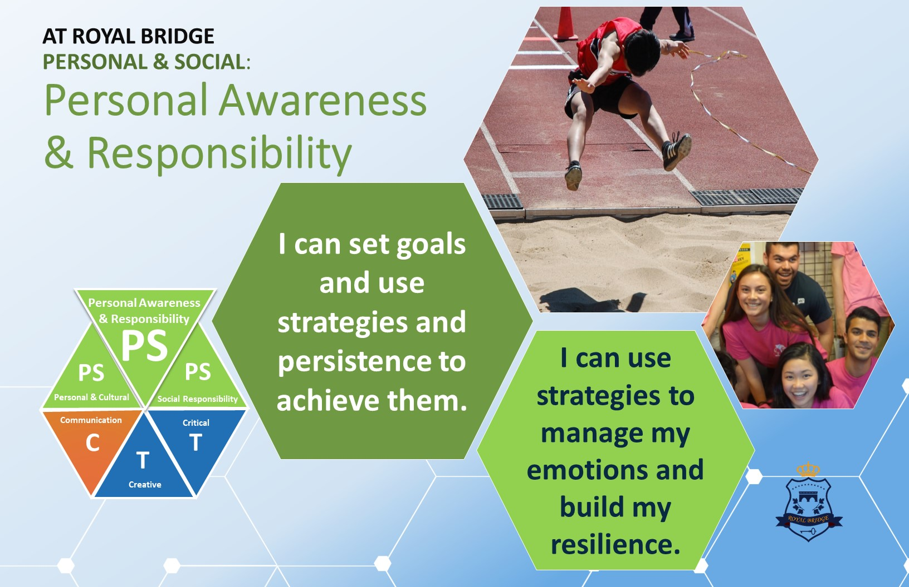

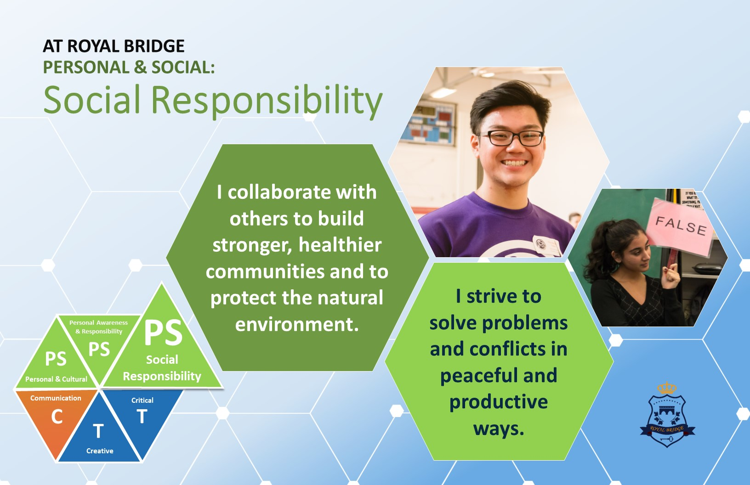

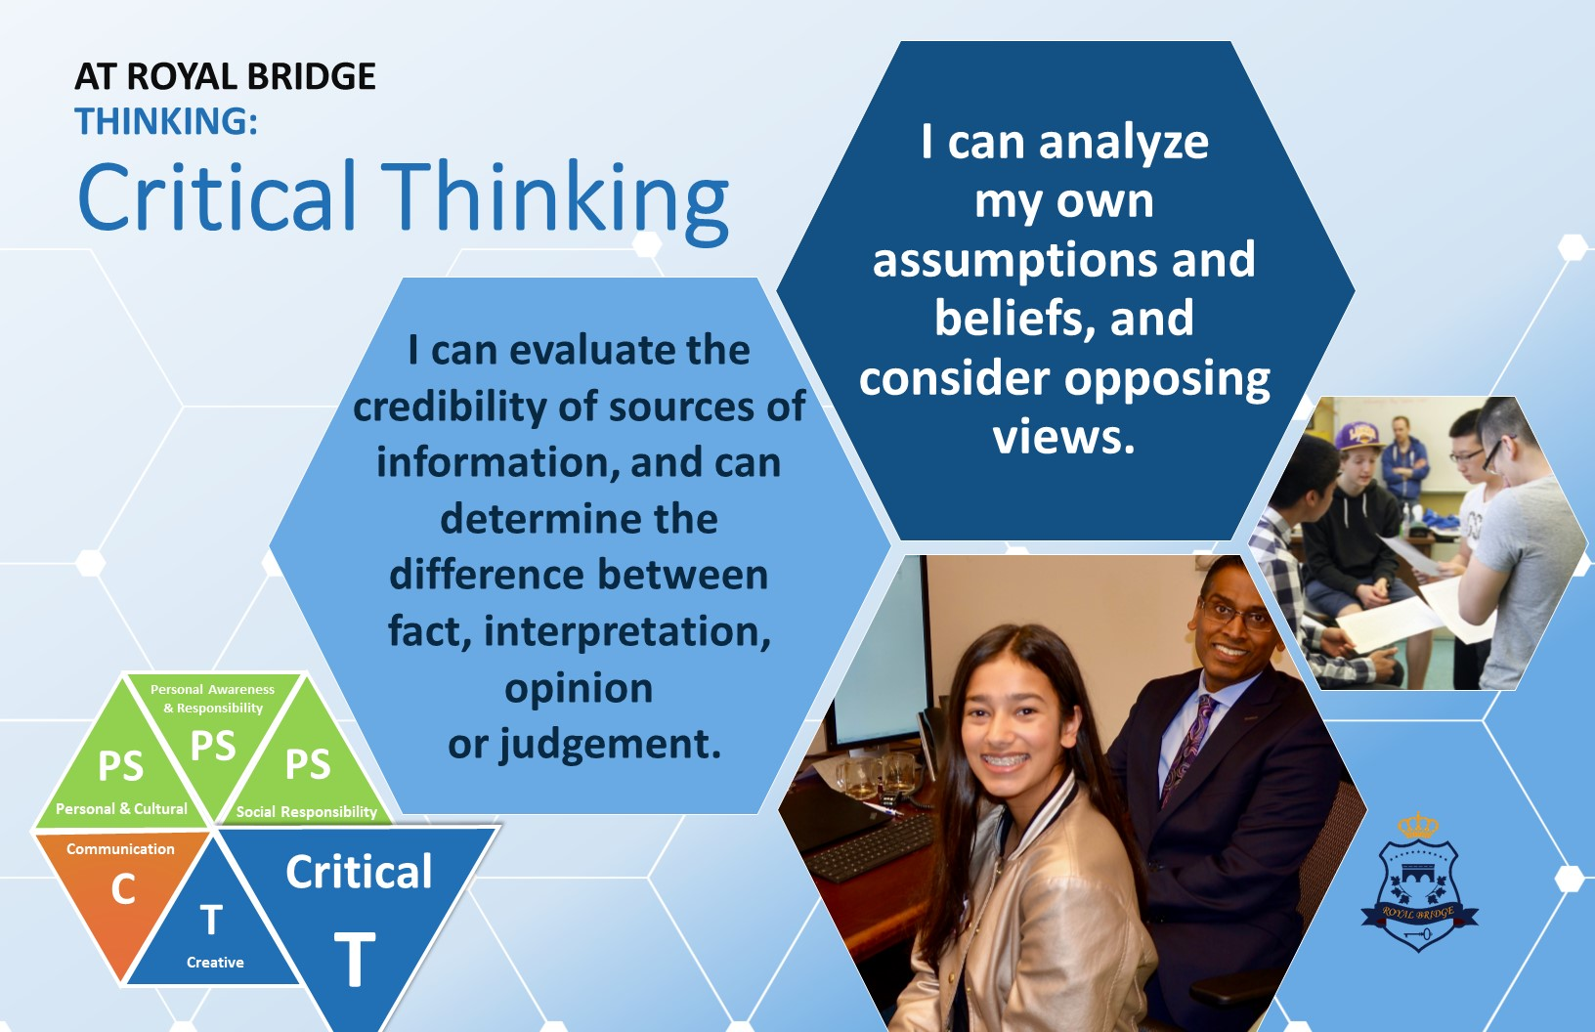

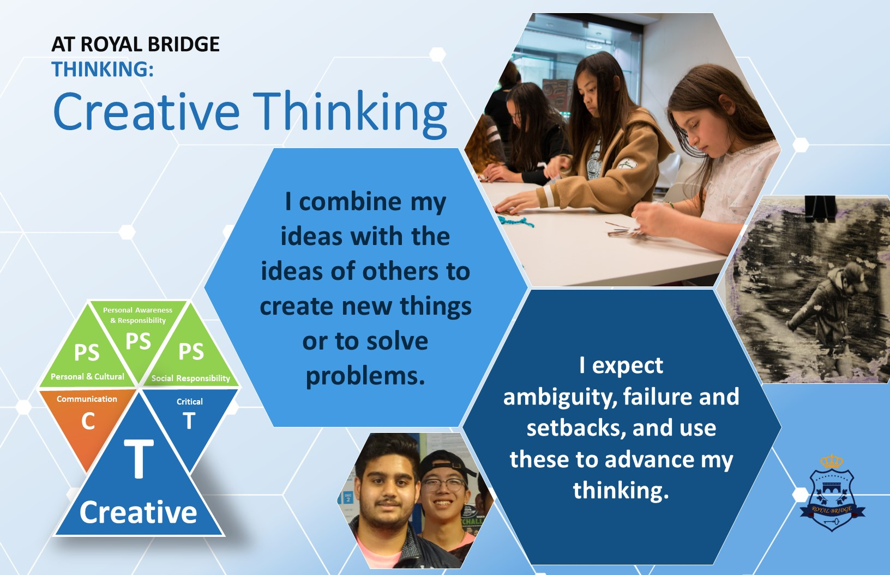

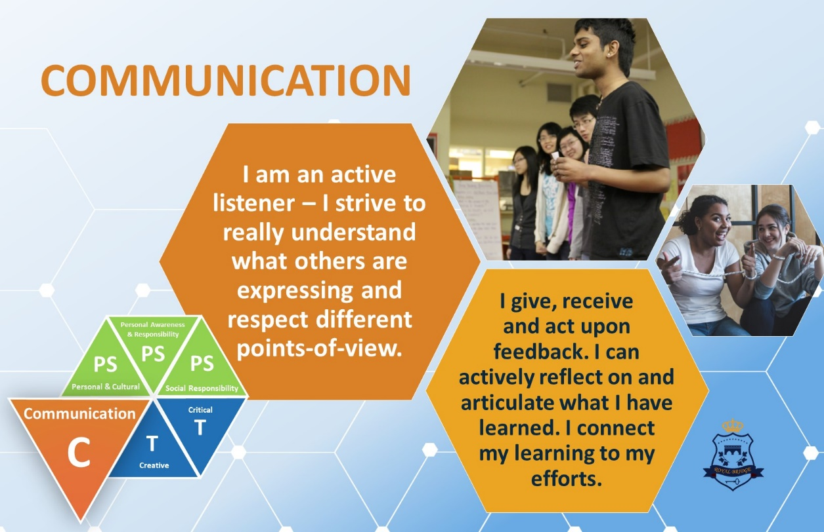

TABLE OF CONTENTS

Section 1 General Info: Location, Mission Statement, Goals, Code of Conduct, p. 2
Discipline Procedures

Section 2 Teacher Responsibilities, Reporting, Classroom Management, p. 6
Field Trips, Academic Integrity Policy

Section 3 Student Attendance p.10

Section 4 Supervision of Instruction, Evaluation Criteria, Counselling
Referrals, Referrals to School-Based-Team, Professional Development p. 11

Section 5 Staff Committees p. 14

Section 6 Child Abuse & Neglect p.15

Section 7 Health & Safety p. 15

Appendix A Major School Rules i

Appendix B Teacher Evaluation Criteria iv

Appendix C Ministry Children & Family Guidelines/ vii
Investigation Protocols

1.

Section 1: General Information
SCHOOL MAP/LOCATION

Royal Bridge High School
301-1123 Westwood St Coquitlam BC
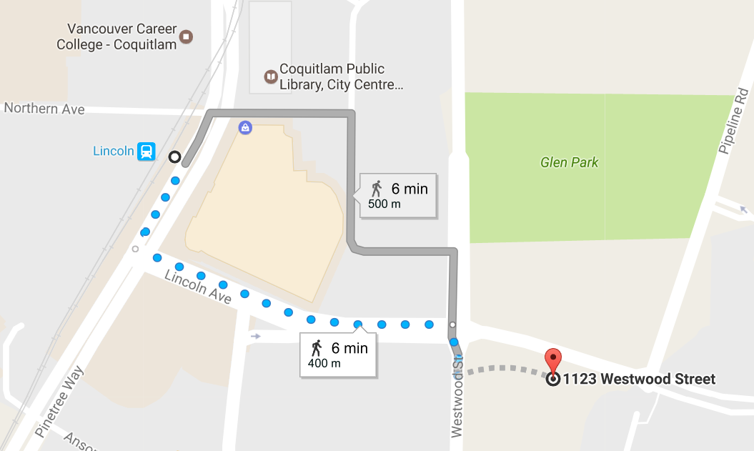

Royal Bridge High School is 400m southeast of Lincoln Skytrain Station, directly south of Glen Park.

Address: #301-1123 Westwood St, Level 3, Coquitlam, BC, V3B 0M1
Royal Bridge High School is at 1123 Westwood Street, Coquitlam, BC, V3B 4S4. Coquitlam is a warm, friendly city within Metro-Vancouver (downtown Vancouver can be reached in 20 minutes). The city provides a safe and clean environment with wonderful opportunities for sport, shopping, international cuisine, and access. Our students stay in Homestay Accommodations with caring families from the community.

2.

VISION STATEMENT

Royal Bridge School is a distinctive and innovative school with the ability to respond to the needs of a diverse student population, while supporting academic, social and life skills. Together with students, parents and stake-holders, our vision is to create an environment built on excellence, personal success, inspirational student leadership, and the acquisition of effective competencies relevant to the demands of the modern world.

BC Curriculum
Students at Royal Bridge High School are enrolled in the British Columbia Ministry of Education school system and have the same opportunities for learning as all students in Canada. Marks are reported to British Columbia Ministry of Education which will issue transcripts and diplomas to our graduates.

“Your bright future begins at Royal Bridge High School.”

SCHOOLGOALS 2020-21

Royal Bridge is a high school whose establishment was based on fostering educational excellence and solid citizenship in our students as well as a recognition that leadership within our communities is an integral part of being a global citizen.

- Continue to develop and foster a Team Climate where creating strong learning opportunities and student successes are at the core of the Royal Bridge experience
- Create a passion and excitement for learning in all students
- Strong Professional Development to develop consistency in teaching practice and a strong focus on the core competencies that are reflected in new BC Curriculum.
- Be aware of the ‘whole child.’ Recognize and celebrate the strengths that are unique to each individual student.
- Stay Safe and positive during the COVID-19 Year!

The ROYAL BRIDGE 6Cs Supports our Students as they learn to:
- Communicate
- Create
- Connect
- Challenge
- Collaborate
- Be Citizens of the Globe

3.

Royal Bridge High School
CODE OF CONDUCT

The teachers and administration of Royal Bridge High School believe that all of our students are capable of success. Learning must be purposeful and take place in a safe environment. Consequently, the school expects that students will actively participate, through effort and punctual, regular attendance, in their assigned education program. We are committed to being an inclusive, bullying and harassment free school. All students must feel safe and secure each day.

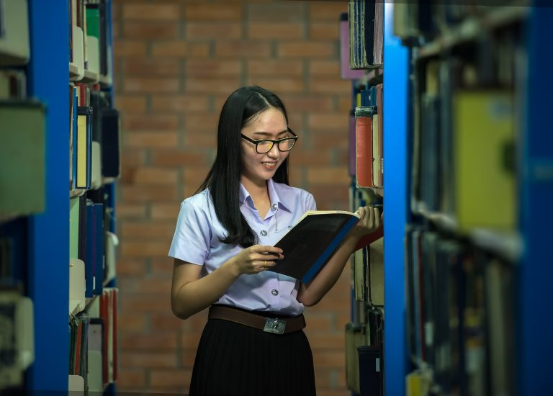
ROYAL BRIDGE HIGH SCHOOL EXPECTATIONS

We at Royal Bridge believe that appropriate conduct should be based on respect for oneself and for others. This guides all of us at Royal Bridge. This is essential to the development of responsible citizens. Student behaviour, dress and decorum shall be in accordance with generally accepted community standards and appropriate for the educational environment. Appropriate behaviour is a responsibility shared among the students, their parents and the school system.

The school believes that our expectations for student conduct are designed to give due consideration to the following:
  - Maintaining a positive and safe learning environment.
  - Respecting the dignity of others, their rights and properties.
  - Providing positive guidelines for student behaviour.
  - Encouraging and promoting educational opportunities for students.
  - Fostering, appropriate to age, a sense of personal responsibility, honesty, and self-discipline.
  - Fostering co-operation, with other students in the achievement of their intellectual, social and career goals.

Through the observance of the above, all students at Royal Bridges hall ensure their participation in a safe, and purposeful education.

4.

Royal Bridge High School does not condone the following:

- Physical violence, intimidation or threats.
- The possession, use or distribution of illegal or restricted drugs, including alcohol.
- The carrying or possession of weapons or simulated weapons.
- Verbal abuse, profanity, racism, and sexism.
- Disruption of the classroom or learning environment.
- Vandalism of school property.
- Internet use which involves bullying of others
As students become older, more mature and move through successive grades, they are expected to demonstrate increasing personal responsibility and self-control.

Please View CONSEQUENCES AND DISCIPLINARY PROCEDURES on the School Website

APPEAL POLICY & PROCEDURES
As a principle of fair procedure, a parent/guardian and/or student may appeal a disciplinary action where the education, health, or safety of the student is significantly affected. Students and parents who wish to appeal a decision affecting their ability to study at Royal Bridge can bring the matter to the School Management Committee for a review. Both parents and the student should be a part of the appeal process. Parents and the student should be prepared to propose a detailed plan for the student to follow to ensure success if they are to be potentially allowed to remain at the school. The plan must include involvement and active support of the parents or guardian. The School Management Committee will meet to review the plan determine the outcome of the appeal. IF a parent is NOT satisfied with the outcome/decision at the school level, they can request intervention from the Ombudsperson at FISA.
Minor matters will be handled in an informal process between parties involved.

5.

SECTION 2: Teacher Responsibilities and Information
At the beginning of the school year, please remember to:
- Update personal information and medical/emergency with the Office Manager (Tina)
STAFF ABSENCE
- Please call or text (and get an acknowledgment) as soon as you are able Please inform school/Principal before 8:00AM of you are going to be absent. Leave information as to availability of room keys, and location of daybook and seating plan.
- Leave adequate information for T.O.C. to carry on your program:
  - Daybook, seating plans
  - Staff handbook
  - Emergency Procedures Manual
  - Medical information for "at risk" students

COURSE OUTLINES/SYLLABI
It is required at Royal Bridge that teachers will provide their students with a syllabus (course outline) at the beginning of each semester for all courses being taught. Typically, these syllabi review course content, assessment and evaluation procedures, and rules of conduct. Preparation of course syllabi are coordinated through the Principal. Copies of all syllabi should be provided to the Principal by the end of Week 1 in each semester.
PARENT/HOMESTAY-TEACHER - INTERVIEW NIGHT
Parent/Teacher Interview Night will be held following the Midterm Report in each semester. The purpose of this meeting is to provide parents/guardians an opportunity to discuss with teachers the progress of students and to establish positive communication between home and school.
Translators are provided as required and when available.

CLASSROOM MANAGEMENT

The keystone of a proper learning situation is the leadership of a teacher who is firm, fair, consistent, and enthusiastic. The following should be noted:

- Maintenance of class discipline is the responsibility of the teacher.
- Time spent in properly organizing your class is time well spent. Your students expect you to establish effective work routines.
- Staff members should refer repeat offenders to the appropriate administrator, but should deal with minor infractions themselves. The Principal should be informed of potential problems.
- Students who commit serious breaches of the rules should be sent to the office:
- Students who are sent out of the classroom should be told to "report to an administrator" and the teacher should give as much detail to the administrator as possible.
- Students sent to the office will be seen by an administrator. After appropriate action has been taken, the teacher will be notified of the current situation.
- Students on an authorized study or who have a free block (as a result of an off-timetable class) should be in the main hall.
- Use your discretion when excusing students from your room during class, but do not allow more than two students out of the classroom at a time.

6.
SCHOOL BULLETINS

Printed each day and placed by sign in sheet.

PROPERTY ISSUES
Valuable items should not be brought to school. Students will be responsible for covering the loss, by theft or damage, of texts, other school supplies and personal belongings.

STAFF SUPERVISION

It is expected that all staff members will check unacceptable student behaviour in the school building, on the school grounds, or at any school function. We are all ‘on duty’ at all times.

FIELD TRIPS

- Please advise the Principal of field trip plans well in advance of the proposed event so that all appropriate documentation can be collected. Teacher sponsors are to complete either a school FIELD TRIP CHECK LIST for local trips, or a REQUEST FOR FIELD TRIP FORM for overnight/outside lower mainland trips.
- All students participating must complete a CONSENT FORM before embarking on the activity. The consent forms may be obtained from the front desk.
- Consent forms must be submitted to Principal for approval at least one week before the date of the activity.
- The sponsor of any activity must submit the names of all students participating in the field trip to the office two days prior to the project. This list should be in alphabetical order, with student numbers and name of teacher. Names of students will be printed in the Daily Bulletin. Teachers should take a list of student contact info with them in case of emergency.
- Students not complying with the specifications of the Consent Form should not expect to participate in a Field Trip.
- In order to ensure that participation in the field trip will be possible for every student in the group concerned, no student should be prevented from participating for financial reasons. Contact the counsellor with the names of students requiring financial assistance.

TEXTBOOKS
Textbook distribution: This goes through the office staff who will keep a record of all assigned texts. Students who lose books during the year should obtain a new text through the office staff who will record the number of the newly issued text and make note of the fact that the original text was lost. Lost books and the replacement costs are the responsibility of the student.
WITHDRAWALS FROM SCHOOL

- Students who transfer or withdraw from school will be required to complete a school withdrawal form.
- Teachers should collect all books or materials from the withdrawing student at this time.
- If the student owes the school money or textbooks the office should note this fact on the form.
- Delete such students from your roll, seating plan, mark book, computer records, etc.

SECURITY

- Before leaving their teaching area at night, teachers should:
- turn off lights & A/c
- Do not leave keys for classroom or classroom cupboards in your mailbox. If you know that you are going to be absent, give your keys to the Office Manager.
- DO NOT LEAVE MONEY, KEYS OR OTHER VALUABLES UNATTENDED ANYWHERE IN THE SCHOOL.
- Instruct students not to bring large amounts of money or valuables to school.
- Staff should be cautious about accepting responsibility for student valuables or money. Students may leave valuables or money in the office if they must bring them to school.
- Be very careful to secure mark books, registers and other important student records.

ROYAL BRIDGE ACADEMIC INTEGRITY POLICY

Royal Bridge High School aspires to develop honest, ethical and accomplished students, capable of being responsible citizens in Canadian society. Education achievement reflects an individual student's subject area performance and honesty acquired skill, knowledge and ability. Students who participate in any activities that undermine the integrity of education achievement at RBHS are serving neither their own nor society's best interests. Some examples of activities that undermine the integrity of education achievement includes:
  - looking at another student's exam papers prior to or during an exam
  - bringing concealed information into an exam
  - acquiring and/or distributing an exam, or information on exam questions, that may be expected to be given by a teacher on a future occasion
  - copying a student's disk and presenting it as one's own work
  - plagiarizing/copying material from other or previous students, the internet, a tutor or other resources without appropriate referencing
  - helping others cheat
  - forging notes or documents
  - altering grades

Staff and administration at Royal Bridge endorse the following policy to ensure the integrity of student achievement.

Students suspected of cheating on exams or handing in assignments done by other individuals without appropriate acknowledgement (Plagiarism) in a bibliography will be disciplined. This also includes plagiarism, defined by dictionary.com as “an act of instance of using or closely imitating the language and thoughts of another author without authorization and the representation of that author’s work as one’s own, as by not crediting the original author.” Incidences of cheating will be recorded in the student’s discipline file.

Examples of Cheating:

- CHEATING is inappropriate referencing from a book or a website
- CHEATING is looking at another person’s answers during a test
- CHEATING is showing someone your answers during a test
- CHEATING is using cheat-notes or unauthorized technology to write an exam
- CHEATING is copying your homework from someone else
- CHEATING is lending your homework to a student so that he or she can copy it
- CHEATING is copying answers written by someone else, such as a magazine, book or website
- CHEATING is getting your tutor or friend or relative to do your work for you

CHEATING is not tolerated at this school, and those caught will face consequences

Consequences:

  - 1st cheating incident: student will receive a mark of zero.
  - 2nd cheating incident: student will receive a written warning from the Principal or Assistant Principal and a zero and possibly an “F” in the course.
  - 3rd cheating incident: student will be put on probation or could face expulsion.

8.
Suggestions for Preventing Cheating
General:
- Review school policy for cheating/plagiarism at the beginning of the school year as part of discussion of expectations of students.
- Take quick action against cheating and make the action known to other students. The consequences should be severe; a zero mark on the test and a phone call home; referral to the administration (suspension or expulsion are considerations for progressive discipline).
- Make certain mark books are well secured and not accessible to student
Test Security:
- PRIOR TO TEST

- Keep all test material out of students' reach; keep exams and quizzes locked up in cupboards and filing cabinets - see department office for storing materials
- Keep briefcase locked and away from students
- Never use students to help assemble/staple test papers
- Avoid take-home exams - these can be done by ghost writers/tutors
- Clean desk tops/counters to erase "useful" information; make sure students clean garbage from inside of desks before test starts
- DAY OF TEST

- Remind students of the rules for test writing and the consequences of cheating
- Seat students well apart from each other; arrange desks into straight rows so that it is difficult to look over shoulder.
- Number the test papers before handing them out; make sure students return the correctly numbered paper
- Isolate "smart sources" at the back of the room (example cell phones) No sharing of calculators or other equipment
- Allow nothing on desks but test paper, answer paper and appropriate tools: all texts to be closed and placed on floor under students' desk; test must be flat on desks at all times
- Absolutely no talking; eyes down on paper - no looking around
- No one is to leave the room during the test (make this known in advance of the test)
- Provide active invigilation; walk around room periodically; do not read or do other tasks - keep constant watch on students; seat particular students in particular desks; stand at the back of the room while observing students
- Use different versions of the same test for different blocks/within the same block (e.g. list questions in different order, or create a number of unique tests for each unit)
- Check pencil boxes/backs of ruler for crib sheets; ask students to remove bulky sweaters or coats as crib sheets may be attached to the inside sleeves

- AFTER TEST
- Never return tests permanently to students; keep all used copies on file under lock and key
- Give students who were absent exam day a different version of the test
- When tests are given back to students, make sure all test papers are collected back before the end of the period.
- Remain alert for evidence of copying when marking tests {unusual use of words, similar phrases, patterns of errors)

9.

SECTION 3: STUDENT ATTENDANCE

REPORTING ATTENDANCE
Teachers are responsible for the accurate accounting of student attendance.

STUDENTS ARRIVING LATE

As a component of our efforts to have staff employ common approaches and to have students best understand expectations, a proactive approach to dealing with students late to class and school has been approved. The objectives of this approach include all teachers using the same system to deal with tardiness.

When a student arrives late to class:
- Do not interrupt instruction; continue teaching.
- At a break in the lesson or ate the end of the period, speak to the student in an objective, non-confrontational manner as to his/her reason for arriving late. Whatever the reason, mark the student tardy on your attendance sheet.
- If the reason is not acceptable the student should be referred to the Principal. The teacher can request the student to see him/her after school to make up missed time.

EXTENDED ABSENCES

Royal Bridge expects that all students will be in regular attendance in each semester. Absence from school limits student achievement and progress. Extended absences can lead to low marks and failure in courses. Students can request time off IF they complete the Student Absence Request Form and have it approved.

Teachers have no obligation to provide work in advance or to give extra time for tutoring and testing after students return, although teachers will assist students as time and circumstances permit. The teaching and other activities that occur day-to-day in class are important and cannot be repeated for absent students.

SUPERVISION
It is important to note the parameters of Supervision that are present at Royal Bridge High School:

- Our Supervisory Responsibility begins once a student arrives at 301-1123 Westwood St. in Coquitlam – our school address.
- Our Supervisory Responsibility ends once a student leaves 301-1123 Westwood St. in Coquitlam. This includes leaving for: (a) a Break; (b) Lunch; (c) Illness; (d) Appointment; (e) End of School Day; and (f) any other reason. In summary, we are not responsible for students when they leave the campus on a non-school sanctioned activity.
Note:
- IF you do not want your child/ward to leave the school during the school day – other than at the conclusion of the school day – please inform the school in writing via email by September 15th, 2020
10.
SECTION 4: The Identification of Satisfactory Teaching; Professional Development; Counselling Services; SBT
RATIONALE
"Supervision" is seen as a supportive, formative process in which the teacher receives both feedback regarding the effectiveness of teaching and help in developing more effective strategies. The effective process will normally be cyclical and incorporate a pre-conference, observation/analysis and post­ conference sequence. There is also the assumption that the supervisor possesses effective data-gathering and feedback-sharing skills.

"Evaluation", on the other hand, is seen as primarily subjective and summative although ideally it includes information which a teacher will find useful in formative terms. Effective evaluation employs the skills and techniques used in effective supervision and add the dimension of a summative report which serves to build a formal professional record for teachers.

RATIONALE FOR REPORTING ON TEACHERS

Formal written reports on a teacher's performance serve:
- to acknowledge strengths and competencies and to reinforce effective practice,
- to identify areas requiring attention and development,
- to provide a base against which future growth can be measured.
- Ensure that Ministry Standards and Directions are being followed.
Reports provided serve as:
- a formal record which teachers can use to develop a professional career record,
- a channel of open communication among educational administrators
An effective report process provides:
- the individual teacher with the protection of due process,
- a systematic means of ensuring that the quality of instruction will be - assessed regularly,
- a visible system of accountability

CHARACTERISTICS OF AN EFFECTIVE REPORT WRITING PROCESS
- A written description of the evaluation criteria is available to professional staff and understood by them.
- A coherent, consistent evaluation process exists and is well understood by staff.
- The purpose of the evaluation process has been articulated and are understood by staff.
- Teachers are given input into the process so that it is clear that evaluation is a shared mutual responsibility.
- Pre-conferences are used to ensure that the above conditions are met.
- Through pre-conferencing, teachers are also given an opportunity to identify personal concerns about the teaching situation so that these can be taken into consideration.
- Sufficient direct observation takes place to ensure that judgments have credible and informal database.
- The process is open and ensures that there are "no surprises" at the end: i.e. relevant feedback is given as the process proceeds and where possible, weaknesses are identified early enough for the teacher to address them.
- Prior to the submission of the final copy of the formal report the teacher is given an opportunity to react to it.
- Follow-up supervision is carried out subsequent to receipt of the report.

Appendix (B) contains Evaluation Criteria

11.
PROFESSIONAL DEVELOPMENT
The purpose of Professional Development is to assist members in:
- Building and strengthening themselves as a body of professional teachers
- Establishing a professional relationship with students/parents
- Developing, discussing and revising educational theories that will be applied to the practice of teaching
- Initiating curriculum and instructional development directed to improve education and which are directly related to BC Ministry initiatives and directions
- Improving the quality of teaching through career-long professional development.

CONFIDENTIAL STUDENT FILES
All confidential files are to be kept with the records clerk in the RBHS office.

COUNSELLING SERVICES

Provide students with assistance in:
  - Orientation to the school
  - Course planning
  - Career or vocational planning
  - Post-secondary educational planning
  - Coping with social and behavioural problems

Provide staff with information concerning:
  - Students
  - Social and family workers
  - Support services from Local Health Authorities
  - Interpreting tests

As a team approach to student discipline at Royal Bridge High School, it is agreed that effective counselling and/or disciplinary action with students should involve parents, teachers, counsellors and administrators. We also agree that in most cases, progressive (i.e. measured gradual) discipline is the most effective approach to solving behavioural and attitudinal problems with students.

SUGGESTED TEACHER ACTIONS TAKEN PRIOR TO COUNSELLING REFERRAL

Depending on the situation teachers may choose one or more of the following actions. Whenever possible, documentation of these actions is recommended.
  - Conference with students
  - Contacted parent by telephone
  - Interim sent home
  - Parent conference
  - Consulted School Liaison Officer
  - Other

12.
POSSIBLE REASONS FOR REFERRAL TO COUNSELLORS

Listed below are a number of reasons for teacher referrals of students to the counsellor. Teachers should provide as much background information as possible to the counsellor regarding the specific concern and the teacher action taken prior to the referral. The counsellor will arrange to meet with the students as soon as possible. Students should not be sent to the Counselor without first contacting the counsellor to ensure the counsellor is available to see the student.

- Absences exceeding 3 classes
- Lack of productivity
- Non-completion of assignments
- On-going anger management
- Conflict resolution
- Personal problems
- Other

POSSIBLE REASONS FOR REFERRAL TO ADMINISTRATORS
- If a student is considered a threat to the safety or orderly learning of class, he or she should be removed immediately and sent to the office. History of the student behaviour should be supplied as soon as possible through phone call or note. For these cases, if the appropriate grade administrator is not available the student will be dealt with by an available administrator as soon as possible.
- On-going serious disciplinary problems should be brought to the attention of the school Principal (Through note or conversation which includes details of previous actions taken) for follow up when appropriate.

Examples of reasons for referral to Principal/SBT (School-Based Team):

  - Chronic absenteeism/tardiness
  - Disruptive behaviour requiring discipline
  - Theft
  - Vandalism
  - Intimidation/threatening/Harassment
  - Deliberate disobedience
  - Violent behaviour
  - Cheating
  - Other

SCHOOL BASED TEAM MEMBERSHIP

(SBT) Meeting Membership
- Counsellor
- Classroom Teacher
- Principal
- Winsey
13.

PURPOSES & PROCEDURES
When concerns are raised about a student, the teachers, administrator or parent/guardian may contact the counsellor who will collect information on the student from all teachers. A Case Conference Meeting will be called by the appropriate counsellor and administrator where all teachers are asked to attend to discuss issues concerning the student. The parent may attend if able or he/she wishes to. At the conclusion of this meeting there should be a plan to assist the student and a date to revisit the issue to determine if further action is necessary.
- To know when and where to go for help outside the school.
- To be able to take "barometer" readings on the school as a whole and to recommend action as needed.

SECTION 5: Staff/School Committees

HEALTH AND SAFETY COMMITTEE
The Health and Safety Committee is represented by members of staff. The committee meets once a month and is concerned with issues that affect the health and safety of the staff and the students. Health & Safety is on every Staff Meeting Agenda.

PROFESSIONAL DEVELOPMENT COMMITTEE
What is Professional Development?
- Attendance at the Pro-D days is mandatory.
- According to the BCTF, professional development is a process of continuous growth, individually and collectively, to learn and grow professionally in order to enhance teaching and learning.
- Professional development is not time spent with students for rehearsals, field trips, practices, study sessions, club meetings, work experience visits etc.

LEARNING RESOUCES COMMITTEE

STAFF COMMITTEE

GRADUATION COMMITTEE
STUDENT COUNCIL
The Student's Council has the responsibility of organizing, governing and coordinating student social activities. All student activities should be brought to the attention of the Students' Council early in the planning stages. Any activity which involves student fund raising must have student counciI approval.

Staff sponsors of student activities should ensure that students involved in the activity have cleared the activity with the Principal.
SCHOOL CLUBS

14.

SECTION 6: Child Abuse & Neglect

DEFINING CHILD ABUSE AND NEGLECT
- Please refer to Page 23 in The B.C. Handbook for action on Child Abuse and Neglect (for Service Providers) 2017
Child: A person under 19 years of age.

Please refer to “Recognizing Child Abuse & Neglect” (pp.23-34) and “Responding to Suspected Child Abuse & Neglect” (pp. 37-56) in The BC Handbook for Action on Child Abuse & Neglect (2017)

You MUST read this to fully understand your Role as a Service Provider and your Duty to REPORT

Inform the school Principal/Winsey and provide him/her with your documentation of the report.

Do not contact the student's parent{s)/guardian{s}, this is the responsibility of the investigating social worker.

SECTION 7: HEALTH & SAFETY

LOCAL HEALTH AND SAFETY ORIENTATION
As an employee at RBHS, the following is intended to provide you with a basic safety orientation. Please read the following and ask questions, as necessary.

- The RBHS Health and Safety Program Manual is located at the front desk.
- The Health and Safety Bulletin Board is located in the staff room.
- The Health/First Aid room and supplies are located next to the main office.
- Summon a first aid attendant by contacting the office. For a serious incident call 911.
- Report all work-related injuries to the First Aid Attendant.
- Report general hazards observed to Winsey/Jim.
- Report a hazardous spill to anyone ASAP
- A copy of the School Emergency and Crisis Response Plan can be obtained in the main office

(We are following The Emergency Management & Planning Guide for Schools, Districts & Authorities (BC Ministry of Education, 2015)

FIRE SAFETY AND PRECAUTIONS

All personnel are reminded to check daily that:
    - exit ways are clear of obstructions
    - doors are free to open
    - fire exit signs are fully lighted when the building is occupied
If a fire is observed, sound the alarm from the nearest fire alarm station. The school will call 911.

CONTINUOUS ALARM
- If the continuous bell sounds, do the following:
- Inform the students of the evacuation route and the meeting place outside. Take a class list.
- Make sure everyone is out of the room and close the door behind you. Ensure your class evacuates the building safely. Stay at least 30 meters clear of the main doors and away from the outside building walls.
15.

- Take attendance and remain with your class outside.
- Depending on the severity of the situation, a Command Centre may be established on the field. In this case, the teacher will send a runner with the attendance to the Command Centre.
- Stay out of the building until the all clear is sounded
NOTE:
- Students outside their classroom at the time of the alarm shall go to the nearest exit and report to their particular class outside the building.
- Students who have a study/free block should report to their teacher.
Points to remember:
- Staff: Attempt to put out the fire, close all doors and windows in the vicinity to prevent air getting to the source of the fire. check alI washrooms.
- Direct any stragglers to leave the building.
- The fire alarm bell must not be used for the recall signal
- Gas and oil-burning apparatus and appliances shall cease, machinery should be shut down, other than those used for heating
- In the event of an actual fire, all teachers having a knowledge of the presence in or about the building of hazardous commodities or chemicals shall notify the principal or person in charge and the Fire Department of the nature and location of the situation.
AREAS OF REFUGE
Areas of Refuge for physically disabled students are located at: ________
In the event of an actual fire, students will be evacuated from the Areas of Refuge by the Fire Department personnel attending the scene.
EXITS TO BE USED DURING AN EMERGENCY EVACUATION
Stairwells and evacuate to parking lot NE of school

EARTHQUAKE IN-CLASS PROCEDURES
      - Drop and take cover
      - Turn away from windows
      - Assume crash position
      - Stay under shelter until shaking stops
      - Listen for instructions

STUDENTS WILL:
- Immediately DROP AND TAKE COVER under desks or tables where possible.
- TURN AWAY FROM WINDOWS
- ASSUME CRASH POSITION - on knees, head down, eyes closed tightly, hands clasped on back of neck or head covered with book or jacket.
- COUNT ALOUD to 60 and remain in sheltered position.
Move with shelters. Desks and tables are likely to travel during strong ground shaking. The duration of ground shaking depends on a number of factors, including the severity of the earthquake.
- BE SILENT AND LISTEN FOR INSTRUCTIONS.

TEACHERS WILL:
- Issue “DROP AND TAKE COVER” verbal command
- DROP AND TAKE COVER for 60 seconds. When the teacher takes cover, it reinforces the importance of earthquake drills. This positive action also assures children that adults will be safe and able to care for them.

16.

- Talk CALMLY to students about the absolute necessity to obey commands. Remind students to take deep breaths to help them stay calm,or encourage them to count softly (in whisper voice). Also advise students to anticipate shorter or longer episodes of ground shaking during actual earthquakes and their aftershocks.

EARTHQUAKE OUT OF CLASS PROCEDURES
(noon-hour, between periods, before and after school)
- Drop and Take Cover
- Move to an Interior Wall
- Turn Away from Windows
- Assume Crash Position
- Stay Still Until Shaking Stops
- Do Not Evacuate Building Until Instructed to Leave

STUDENTS WILL:
- Immediately DROP AND TAKE COVER with books or jackets held over head. Clasp hands behind neck and cover side of head with arms. Physically disabled students will stay in wheelchairs and cover heads.
- Move to an interior wall and TURN AWAY FROM WINDOWS, shelters or heavy objects such as lockers that may fall.
- ASSUME CRASH POSITION, except for physically disabled students who will cover their head if possible.
- Stay still until shaking stops. Count aloud to 60.

- BE SILENT AND LISTEN FOR INSTRUCTIONS. Do not leave building until instructed to leave
TEACHERS WILL:
- Issue DROP AND TAKE COVER order in immediate area.
- Also DROP AND TAKE COVER for 60 seconds.
- Talk CALMLY to students in immediate area about the absolute necessity to obey commands.
- Follow procedure for evacuating building AFTER shaking ceases.

EARTHQUAKE EVACUATION PROCEDURES INSIDE:

TEACHERS WILL:

- Evacuate the building after shaking ceases
- Evacuation will take place when the teacher decides the shaking has ceased sufficiently, and it is prudent to move out of the building
- When leaving classrooms according to the pre-arranged plan, teachers should make every effort to take with them class lists (attendance sheet or seating plan), paper and pen. Check with your "buddy" class when evacuating. If there are seriously injured persons who cannot be moved, arrange for one teacher to remain.
- Do not use elevator - Use exit listed. Also, be prepared to use an alternate exit should your designated exit be blocked.
- Once classroom door is closed and locked, a large "X" should be placed on the door with chalk to indicate that no one is inside.
- Teachers will lead classes to designated area (where?) and will remain there until instructed otherwise. Instruct students that they must remain in their assembly area under your supervision until permission to leave is given by the COMMAND CENTRE.

17.

OUTSIDE, TEACHERS WILL:

- ASSEMBLE THEIR CLASS IN AREA DESIGNATED - away from buildings, fallen trees and wires, etc...
- STAY WITH THEIR CLASS GROUP, or report to Command Center if they do not have a class group.
- Remain with the students in their class group until an emergency first aid station is established.
- ASAP - TAKE ROLL OR LIST STUDENTS. Send notice to Command Center immediately, of any student who is not with the group who should be, noting possible whereabouts, i.e. at library, or absent from school. Take roll periodically throughout the disaster period. Take note of the location of injured people and the extent of injury as you may not be able to stay with the injured party. Send "Nil Report" to Command Center if no student is absent: every class and teacher needs to be accounted for.
- STAY ON SITE, AWAIT FURTHER INSTRUCTIONS AND DO NOT LET STUDENTS WANDER. Note on class roster the name of anyone who for any reason has left the class group. NOTE the time the student departs the group, the circumstances of his/her leaving, and any information on current whereabouts. Record any first aid given to students.
- DO NOT enter buildings unless instructed to do so.

IN THE EVENT OF AN ARMED INTRUDER
The School-Wide Security Alert System protects staff and students from a threat such as an intruder, when it may be more dangerous to leave the building than to stay in a locked room.

CODE RED: FULL LOCK DOWN
- If the intruder is inside the school, notify all students and staff.
- Calmly state: “CODE RED, CODE RED - FULL LOCK DOWN”
- SECURE YOUR ROOMS. THIS IS A FULL LOCK DOWN.
CODE YELLOW: PARTIAL LOCK DOWN
- If the intruder is on the grounds, notify all students and staff.
- Calmly state: “CODE YELLOW, CODE YELLOW. THE OUTSIDE DOORS OF THE SCHOOL ARE LOCKED. NO ONE MAY EXIT OR ENTER THE SCHOOL.CODE YELLOW.”

CODE GREEN: ALL CLEAR

CLASSES NOT IN SESSION: (before and after school, lunchtime, between classes).
- Direct all staff and students to the nearest where space is available.
- Follow procedures under CODE RED or CODE YELLOW as appropriate.

If you SEE an armed intruder:
- Dial 911 and tell us if possible, two pieces of information
WHERE he is and WHAT he is armed with
- Proceed to lockdown steps above.

18.

STUDENT ACCIDENTS, INJURY AND ILLNESS

The following is a summary of procedures in case of injuries that occur at school:
  - It is primarily the responsibility of the parent or guardian to provide medical attention for their children.
  - In the case of an injury that occurs at school, if the parent or guardian cannot be contacted and the injury is deemed to be serious, the school staff will be prepared to act in place of the parent or guardian.
  - The designated staff member with first aid training will take care of all injuries. If the designated staff is NOT available the principal or other staff members may provide first aid to the student.
  - If the student requires medical attention but the injury is not considered of an emergency nature, an effort will be made to contact the parent and someone from the school may accompany the student to the hospital/doctor/dentist.
  - In case of minor injuries, normal activities can resume after first aid has been administered.
  - If the injury is not severe, but the student is not well enough to stay at school, the school will attempt to contact the parents and ask them to come and pick the student up.
  - An effort will be made to contact parents in case of head injury, even if the injury appears to be minor.
  - Before a student leaves the school because of accident or illness, permission of the school must be obtained and the parent or guardian must be informed.
  - Accidents involving serious injuries must be reported by the first aid attendant.
- Parents, guardians or an alternative adult will be contacted about any injury as quickly as possible, so they can assume responsibility for providing treatment to the students.
- If the student has been delivered to the emergency department, the hospital assumes responsibility for contacting the parents or guardians and the family doctor, if the school has not been able to contact them.
- If follow-up treatment is anticipated, details of phone calls to parents or guardians (content, dates and times, and who made the calls), should be noted.
- If a parent/guardian has provided written information about a student's medical problem, the school administration should inform staff involved with the student about the condition and procedures that may be necessary in case of an emergency.
- The school administration should have the phone numbers of parents or guardians, an alternative responsible adult and the family doctor and dentist, so they can be contacted in an emergency. The RBHS Contact Form which should be updated by the school annually, serves this purpose and includes space for Medical Alert Information. The information should be available to school staff and the school Community Health Nurse.
- The Community Health Nurse will assist the school administration in establishing health care guidelines for students with identified medical conditions.
- It is primarily the parents' or guardians' responsibility to ensure medical attention for their children, but each case must be judged according to circumstances. If the parent or guardian cannot be contacted quickly, school staff should be prepared to act in place of the parent or guardian.

19.

- The school is responsible for the student until he or she is delivered to the care of his or her parent or guardian or to responsible, medically trained people, such as ambulance attendants or hospital emergency department staff.
- The designated staff member with first aid training will take care of all sick and injured students. In this document “ill ness” refers to short term occurrences only. The school nurse, when available on site, may provide assistance.
- If neither the designated staff member nor the school nurse is available, the principal or other staff members may provide care for sick and injured students.

PROCEDURES FOR POTENTIALLY SERIOUS INJURIES

Serious injuries include:
- breathing difficulties
- head injuries with loss of consciousness
- head injuries without loss of consciousness but with symptoms of neurological impairments
- eye injuries
- possible harmful substances in the eye
- suspected or definite fractures
- teeth knocked out or loosened
- open wounds or cuts more than 3 cm long
- suspected spinal cord injuries
- any injury requiring more than minor first aid

Call 911 if an ambulance is necessary to transport a student to a hospital emergency department. When calling an ambulance, this information must be provided:
- the name and address of the school
- nature of the illness or type of injury
- whether the patient is conscious or unconscious
- if there is breathing difficulty
- the school office telephone number
- the location in the school of the injured person
- the school entrance the ambulance crew should use.

- If the child is deemed to require the attention of a physician/dentist for a non-emergency care, an attempt must be made to contact the parent or guardian, and someone from the school may accompany the child to be the hospital/ doctor/dentist.

- If the injury is severe, call an ambulance, notify the parent immediately; someone from the school may accompany the child to the hospital.

- Accidents involving serious injury must be thoroughly documented.

PROCEDURES FOR MINOR INJURIES
Injuries are minor if normal activities can resume after first aid has been administered and no further signs or symptoms appear that require additional assessment or treatment.

20.

In case of minor injuries, an Accident Report should be filled out.
- Give the student a copy to take home
- File a copy in the school health room
- A copy may be mailed to the student's home address
- If the injury or sickness is not severe, but the child is not well enough to stay at school, the school should contact the parents/guardians and ask them to come and pick the child up, if necessary.

- In cases of minor head injuries, the school should give the student a copy of Recommended Procedures Following a Head Injury, in addition to the school's Accident Report, to take home.

THINGS TO KEEP IN MIND WHEN PROVIDING ASSISTANCE TO SICK OR INJURED STUDENTS:

- School personnel should not recommend treatment. This is the responsibility of the attending physician.
- RBHS pays ambulance or taxi costs for transporting any injured student from school to a hospital.
- Taxi bills are to be paid by the school and a request for reimbursement should be sent to the office.
- If follow-up treatment is anticipated, details of phone calls to parents or guardians (content, date and time and who made the calls) should be noted on the Schools Protection Program Incident Report form.

FOOD ALLERGIES
Anaphylaxis is a severe allergic reaction which, if left untreated, can lead to sudden death. Examples of potentially life-threatening allergens include peanuts, shellfish, fish, cow's milk, eggs and insect venom. An anaphylactic reaction can begin with itching, hives, and nausea but can be quickly followed by severe breathing difficulties, a dropin blood pressure and shock which are potentially fatal. Fortunately, such potentially life-threatening allergies are rare.

RECOMMENDED STRATEGIES IN THE PREVENTION/MANAGEMENT OF ANAPHYLAXIS
The following general recommendations provide assistance in the development of school-based policies regarding students who have life­ threatening allergies.

INFORMATION AND AWARENESS TO MINIMIZE RISK
- Parents have the primary responsibility of informing school personnel regarding their child's severe allergy. RBHS needs to collecting health information and establish medication protocols for individual students.
- Community health nurses provide consultation for school staff, students, and parents regarding severe allergies. They participate in the development of a plan of care and in the training of staff in the use of epinephrine auto-injectors (such as EpiPens and Ana-Kits).
- All staff members in a school (teaching and non-teaching) should be aware or students who have potentially life-threatening allergies. This includes substitute teachers and school volunteers. School administrators should ensure that staff who may be in a position of responsibility for students with anaphylaxis receive personal training in the use of auto-injectors of epinephrine. This may include first aid attendants, teachers, noon-hour supervisors, bus drivers and cafeteria staff.
- The affected student's classmates need information on the allergy in a way that is appropriate to the age and the maturity level of the students. This should be done in consultation with the affected student and his or her parents.

21.

AVOIDANCE OF FOOD ALLERGENS

It is not possible to achieve a completely allergen-free school as there can be hidden or accidentally introduced sources. However, school-based policies and strategies can be developed to help reduce the risk of exposure. Various factors need to be considered such as the age and maturity of the student, the organization and physical layout of the school, and the properties of the allergen itself. Some suggestions include the following:

Establish safe lunch room and eating area practices:
- Require at-risk students to eat food prepared at home
- Provide an "allergen-free" eating area for the at-risk student
- Avoid trading and sharing of foods, food utensils and food containers with students who have severe food allergies
- Clean eating surfaces with soap, water, and paper towels and encourage hand-washing by staff and students (thus reducing risk of exposure to any food allergen residue).

Avoid exposure during school activities:
- Cooking classes and crafts - the use of food in cooking classes and crafts may need to be restricted or modified depending on the allergies of the students
- Field Trips - Safeguards need to be in place to ensure the safety of at-risk students during school field trips, especially when travel time to an emergency ward is extended.
- Examples could include having extra EpiPens or Ana-Kits available and training additional staff persons in handling anaphylaxis emergencies. Holidays and special celebrations - Food is often associated with special occasions. These foods may need to be restricted or modified depending on the allergies of the student. Recommending the use of non-food treats for students during celebrations can be helpful.
EMERGENCY RESPONSE PROTOCOL
Since it is impossible to reduce the risk of accidental exposure to zero, a student with severe allergies may require emergency life-saving measure while at school.
- Each at-risk student should have an emergency plan developed in cooperation with the parents, the student's physician, and the school community health nurse. This plan should be kept in a readily accessible location.
- An up-to-date student should have an emergency plan developed in cooperation with the covered, secure, unlocked area of quick access. The location of the injectors should be known to all staff and classmates.
- If mature enough, students should be encouraged to carry an injection kit in a fanny pack at all times. All students regardless of whether or not they are capable of epinephrine self-administration will still require the help of others because of the severity of the reaction may hamper their attempts to inject themselves.
- Further information on the use of epinephrine is available from the community health nurses.

22.

APPENDIX A: MAJOR SCHOOL RULES

UNACCEPTABLE BEHAVIOURS
To ensure a safe learning and living environment, all students need to know that the school cannot and will not tolerate any of the actions and behaviours described below. Direct involvement in any of these behaviors will result in disciplinary action from the school; indirect involvement in these behaviours may also result in consequences when required.

It is a student’s responsibility to know, understand and follow these rules to the best of their ability. If students have questions or are unsure about a particular rule, they need to ask a school staff for more information. If students have concerns about their own safety or the safety of others as it relates to these rules, they need to inform a staff member as soon as possible. We have a zero tolerance for Bullying, Harassment, Violence or any forms of Prejudice.

VIOLENCE & FIGHTING
Students are expected to refrain from acts of violence toward their peers, which include: anything meant to cause physical harm (punching, slapping, kicking and the like); intimidation (making someone afraid); verbal abuse (including using sexual, racial, homophobic or other offensive slurs); and hazing (an activity expected of someone that abuses, shames, or puts them in danger). If a student is physically violent toward a staff member, the student may be expelled immediately.

Students are not to resort to fighting with one another to solve problems. Students should be willing to participate in mediation to resolve conflict between both parties. Factors important to decisions include: the level of physical violence, degree of harm, damage to property, timely resolution of the conflict, etc.

WEAPONS
Weapons are expressly forbidden, including any object used to simulate a weapon or cause harm, such as but not limited to: sharpened objects, projectiles, high-voltage electrical devices, blunt objects, objects used to choke, etc.

DEFIANCE
Students are expected to follow the lawful instructions of staff in order to best ensure the safety and well-being of the school community. If students are defiant, they will be given consequences (which can exclude suspension and expulsion). Defiance includes refusing to listen to staff, arguing angrily and consistently ignoring the recommendations of staff. Repeated defiance will result in more serious consequences. Intimidation or threatening behaviour toward any staff member will be treated very seriously.

HARASSMENT & BULLYING
Harassment is seen as troubling, bothering and/or annoying someone continually. It is any type of behaviour that is not wanted, offensive or intrusive. Bullying can be defined as using strength and/or power to frighten or hurt others. It is usually aggressive, intimidating, and used to gain advantage over someone else. Sexual Harassment can be defined as unwelcome sexual advances (i.e. gestures), unwelcome requests for sexual activities, and other unwelcomed verbal or physical conduct of a sexual nature.
Some examples of bullying and harassment are as follows:
- Demanding favours (through pressure or force), exercising verbal threats and excessive play fights, or intimidation by physical proximity, circling or pushing;
- Ignoring, isolating, or excluding from what is going on;
i.

- Teasing; constantly criticizing others' differences such as gender, racial or language background, sexual orientation, body shape, and so on.
Students who experience or witness bullying or harassment need to seek help from a staff member as soon as possible. Taking or sharing of sexual images of any student is not tolerated at the school. It is important to note that the Canadian Criminal Code views the following as “child pornography”, an illegal offense: possession of any image that shows a person who is under the age of 18 years and is engaged in explicit sexual activity, the depiction, for a sexual purpose, of a sexual organ of a person under the age of 18 years, and so on.

OBSCENE BEHAVIOR
Students are not to engage with one another in sexual activity on campus. Possession or viewing of pornography is not allowed. Sustained and inappropriate public displays of affection (e.g. kissing,sitting on each other’s laps, etc.) will result in consequences depending on the nature and frequency of the behaviour. Students are not to access the halls of students of the opposite gender, and should not seek to isolate themselves in out-of-bounds areas of campus.

DRUGS
Using, possessing, or supplying drugs (including marijuana) or direct drug paraphernalia is extremely serious and will result in the student being expelled from school. As possession of drugs (such as marijuana) is illegal in BC, the school police liaison may be involved or contacted to advise in the matter. Students found abusing pharmaceutical drugs or other potentially dangerous substances will also face serious consequences. Students attending events in which drugs are present will be given serious consequences based on the circumstances.

Royal Bridge High School Policy on Marijuana (Cannabis) Usage
Although non-medical marijuana is now legal in Canada for recreational use, there are some facts you must know:
- You have to be 19 to buy, use or possess - this is the same for alcohol purchase and usage
- If you are under 19, it is not legal to possess or use
- Even if you are 19, marijuana use at or around the school is nor permitted
- Showing up at school smelling of marijuana (which means usage) may lead to suspension or dismissal from school
- Driving while using marijuana could result in criminal charges
- Dismissal from school for marijuana, alcohol or any drug abuse will part of your permanent record. This could impact your study visa.
- Serious issues may be reported to the consul of your country. It is important to note that drug use/abuse is not tolerated in many countries, like China.
- Please Do NOT make this an issue which impacts your study in Canada and perhaps even your life and ability to travel or go to school abroad.

ALCOHOL
The legal drinking age in B.C. is 19 and anyone under that age is considered a ‘minor’ under the law; however, for safety reasons Royal Bridge students of any age should not consume alcohol at any time (including for students aged 19 or older). Students found using, possessing or supplying alcohol will be put on behaviour probation and given appropriate consequences. Students attending events in which alcohol is present will also be given serious consequences based on the circumstances. For safety reasons, students will be subject to a breathalyzer test if they are suspected of being under the influence.

It is important to know that according to BC laws, it is illegal for minors to be caught with liquor, buy liquor, or try to buy liquor using false ID. Minors must also not go to establishments that sell liquor for consumption unless with a parent or guardian.

ii.

SMOKING & VAPING
Royal Bridge is a smoke-and vape-free school. For all Royal Bridge students, no smoking or vaping is permitted on campus. Royal Bridge High School recognizes that smoking and the use of tobacco products present a significant health and safety hazard that can have serious consequences for the smoker and non-smoker and the safety of the school. It is important to know that, according to BC laws, a person must not smoke or use tobacco in or on school property. It is also illegal to sell or give tobacco to anyone under 19.

IF you are caught SMOKING or VAPING inside the building you will be fined and may be asked to leave the school.

This is VERY SERIOUS. It is against the Law.

IF you smoke or vape outside the school it must NOT be on the property our school building sits on. You CANNOT be near the restaurant, the corner of Lincoln & Westwood or in front of any shops or stores. Remember: we have young kids and families going by and into our building.

Fines & Penalties

IF you are caught Smoking or Vaping INSIDE the school:
First Time: $125 Fine
Second Time: $250 Fine
Third Time: $375 Fine + Potential Removal from School

IF you are caught Smoking or Vaping OUTSIDE the school on School Property:
First Time: $50 Fine
Second Time: $100 Fine
Third Time: $150 Fine + Suspension from School

PLEASE NOTE: A suspension or removal from school could occur at any stage if the circumstances are serious enough.

THEFT, VANDALISM OR PROPERTY DAMAGE
Students who damage, vandalize or steal the property of the school, their homestay or others must pay for replacements or repairs and will be given serious consequences depending on the circumstances. Anyone who accidentally damages something around the school should tell a staff member immediately.

iii.

APPENDIX B: EVALUATION CRITERIA
(From BCTF)

Under each criterion below, are suggested examples of related teacher behaviours. Administrators look forward to a discussion of the criteria with teachers so that the basis for evaluation is mutually understood.
- "The employee seeks knowledge of the social, emotional, intellectual, cultural and physical characteristics of the pupils who he/she teaches with the objective of furthering their educational growth."
- Participates as necessary in school-based team meeting.
- Becomes familiar with information contained in individual student files
- medical, diagnostic assessments, D.EA.P. results etc.)
- Where appropriate, seeks information/advise from counselor, psychologist, speech/language specialist, nurse, school doctor, district personnel, etc.
- Becomes familiar with and is sensitive to the unique cultural background or ethnic heritage of children
- Assists in the integration of special education/ESL students.

- "The employee":
- Plans with definite purpose and clear objectives in mind; Communicates these purposes and objectives to the students;
- Establishes appropriate procedures for assessing, recording and reporting pupil performance to parent(s)
- Uses diagnostic tools, which are pertinent to the course and program objectives.
- Identifies present achievement level for each student. Prepares a diagnosis for each student.
- Prepares both short and long-term objectives for the course or program. Prepares objectives in terms of specific student performance.
- Prepares objectives upon which useful data can be collected. Develops individual objectives for exceptional students.
- Ensures course objectives are understood by students and parents. Submits term previews to principal.
- Plans lessons which are consistent with the stated objectives. Compiles data/representative samples of student work.
- Participates with S.D.C. teacher in development of I.E.P.'s (Individual Education Plans).

- “With due consideration for individual differences, the employee works to involve students in experiences and activities designed to develop skills and stimulate thought."
- Involves students in the direction of their own education
- Plans lessons which include individual and group activities appropriate to the needs of all students.
- Uses resource materials which are appropriate to the instructional objectives.
- Uses student feedback in planning instruction.
- Establishes feedback processes to monitor student understanding. Establishes a physical environment which is stimulating and "relevant" to current instruction.
- Clearly distinguishes between academic and affective objectives.

- "The employee uses instructional techniques that promote questioning, speculation and originality."
- Demonstrates a knowledge of group dynamics and motivation theory Paces and varies the activities within a lesson according to the needs and interests of students.

iv.
- Uses students’ ideas and cultural backgrounds as a source of instructional strategies.
- Uses effective motivational strategies.
- Explains material in clear, graphic terms
- Uses community and other resources to enrich instruction.

- “The employee works at keeping his/her knowledge current and his/her teaching techniques effective in the subject areas he/she undertakes and agrees to teach.”
- Takes an active part in Pro-D activities
- Is an active member of professional organizations. Demonstrates a currency in educational readings Gives workshops in subject areas.
- Attends and participates in school and district professional development activities
- Exhibits a willingness to adjust to the changing educational needs of the district
- and to new expertise in the profession

- “The employee practices classroom management suitable to the growth and development of the pupil.”
- Gives directions in a clear, concise manner.
- Fosters an atmosphere in which students remain on task.
- Ensures that activities of individual pupils tend to enhance rather than interfere with the
- learning of others.
- Exhibits consistency and fairness when dealing with pupil ehavior. Makes effective use of instruction time
- “The employee, as a member of the staff, participates in the development and implementation of the philosophy and practices of the school and works in cooperative ways with colleagues to promote the welfare of pupils.”
- Assists in school policy-making, e.g.:’ School Profile, Goals, Vision Statement, etc
- Supports school goals and policies or works positively to alter them. Translates school goals into classroom objectives.
- Plays an active role in staff committees
- Is aware of works to implement Royal Bridge High School long­ term/short-term goals.
- Is familiar with and can implement our “Emergency Procedures” plan
- “The employee fosters a climate of mutual respect between himself /herself and his/her pupils.”
- Treats both pupils and adults with consideration and courtesy. Fosters am atmosphere that promotes participation by all.
- Knows and uses student’s names
- Encourages and considers student comments and suggestions. Is approachable by the students.
- Implements “Action Plan for the Improvement of d Multi­ Cultural education at RBHS.
- Demonstrates interest and concern in the well-being of others. Demonstrates interest and concern in school climate.
- Interacts positively with students outside of the classroom.
- Makes explicit to students expected standards of appropriate ehavior and helps students to meet those standards.
- “The employee seeks to invoice parents in the educational process and gives and obtains information that assists in the development of the pupil.”
- Uses parents, support staff and others to enhance the learning of individuals and groups.
- Ensures that parents/pupils understand the bases and procedures used in evaluation.
v.

- Provides pupils and parents with clear and current appraisals of individual achievement.
- Distinguishes between continuous evaluation (formative) and evaluation for
- the purpose of formal reporting (summative).
- Keeps records which reflect variety and depth of assessment

10. "The employee cooperates with colleagues and associated personnel in utilizing existing educational services and resources for the benefit of the pupils.”
- Uses a variety of appropriate media effectively and efficiently. Plans cooperatively with colleagues.
- Accepts responsibilities in the wider life of the school Shares ideas and resources with others.
- Follows district policies and where appropriate, adopts a construction stance towards making the team more effective.
- Ensures that the school and classroom environments are safe for children.
11. "The employee at appropriate times, reviews with colleagues, students and their parents the practices employed in discharging professional responsibilities."
- Tests to see if program is meeting student needs.
- Tests to see if instruction is achieving states objectives.
- Alters instructional strategies and content to achieve objectives.
- In considering and implementing policies, places the good of the pupils first.

vi.

APPENDIX C: CHILD PROTECTION

PART 1: Child, Family & Community Services Act

Section 13: When Protection is Needed

- A child needs protection in the following circumstances:
  - if the child has been, or is likely to be, physically harmed by the chiId's parents;
  - if the child has been, or is likely to be, sexually abused or exploited by the child's parent;
  - if the child has been, or is likely to be, physically harmed, sexually abused or sexually exploited by another person and if the child's parent is unwilling or unable to protect the child;
  - if the child has been, or is likely to be, physically harmed because of neglect by the child's parent;
  - if the child is emotionally harmed by the parent's conduct;
  - if the child is deprived of necessary health care;
  - if the child's development is likely to be seriously impaired by a treatable condition and the child's parent refuses to provide or consent to treatment;
  - if the child's parent is unable or unwilling to care for the child and has not made adequate provision for the child's care;
  - if the child is or has been absent from home in circumstances that endanger the child's safety or well-being;
  - if the child's parent is dead and adequate provision has not been made for the child's care;
  - if the child has been abandoned and adequate provision has not been made for the chiId's care;
  - if the child is in the care of a director or another person by agreement and the child's parent is unwilling or unable to resume care when the agreement is no longer in force.
- For the purpose of subsection (l)(e), a child is emotionally harmed if the child demonstrates severe
  - anxiety,
  - depression
  - withdrawal, or
  - self-destructive or aggressive behaviour.

Section 14: Duty to Report Need for Protection

- A person who has reason to believe that a child:
  - has been, or is likely to be, physically harmed, sexually abused or sexually exploited by a parent or other person, or
  - needs protection under Section 13 l(e) to (k)
must promptly report the matter to a director a person designated by a director.

- Subsection (1) applies even if the information on which the belief is based:
  - is privileged, except as a result of solicitor-client relationship, or
  - is confidential and its disclosure is prohibited under another Act.

- A person who contravenes subsection (1) commits an offence.

- A person who knowingly reports to a director, or a person designated by a director, false information that a child needs protection commits an offence.

- No action for damages may be brought against a person for reporting information under this section unless the person knowingly reported false information.
- A person who commits an offence under this section is liable to a fine up to $10,000 or to imprisonment for up to 6 months, or to both.

- The limitation period governing the commencement of a proceeding under the Offence Act does not apply to a proceeding relating to an offence under this section.

In a Public School there are many layers of oversight. At Royal Bridge, we might well have to consult/work with MCF and local law enforcement.

vii.

PART 2: Investigation Procedures for Alleged Abuse by an Employee

School Administrative Officer

The School Administrative Officer, in consultation with MCF and local law enforcement, will manage the investigation at the school level with respect to liaising between students, parents, and employees. He/she will identify support needs, access appropriate resources and/or provide suitable referral s for the individuals affected. (See also roles of Child Abuse Prevention Coordinator and Ministry for Children and Families)

Independent Interviewer

Royal Bridge will consult with MCF to utilize independent interviewers (if required) who have credentials and experience the child protection field. The independent interviewer will be contracted to conduct the investigative interviews. The expert will provide to RBHS a verbal report followed by a written report which contains the nature of the allegations, the results of the interviews and an assessment of the situation. The RBHS then decides on the appropriate course of action.

Royal Canadian Mounted Police
Where the matter appears to be of a criminal nature, the Royal Canadian Mounted Police will conduct their own investigation. RBHS and RCMP investigations, although separate and distinct, will be coordinated whenever possible. RBHS will conduct an internal investigation following consultation with the Royal Canadian Mounted Police.

Ministry for Children and Families
The Ministry for Children and Families will receive a report from the Winsey Choi/Principal that a child has been sexually abused by a school employee and will ensure that the RCMP has been notified. Ministry for Children and Families will participate with the RBHS & RCMP (where the matter appears to be of a criminal nature) throughout the investigation and respond to any concerns that a child may be in need of protection. Ministry for Children and Families will also provide support and referral for the children and families affected.

COMMUNICATION PLANNING
These protocols are designed with the protection of the confidentiality of both the alleged victim(s) and the alleged offender having the utmost importance. The protocols take into account the Freedom of Information and Protection of Privacy Act. However, RBHS has a responsibility to keep parents and staff informed of matters that may affect children and students respectively. To that end, the following guidelines must be followed:

- RBHS will consult external agencies to develop a communications plan for managing the release of information relevant to the specific investigation underway. We will ensure a cohesive and coordinated approach to the release of information.
- RBHS staff will not release information except in accordance with the communication plan.
- The communications plan will take the following into consideration:

- any information released to the public should be vetted through legal counsel and, when applicable, the Royal Canadian Mounted Police.
- information will be released on a "need to know basis."
- public release of information must be in accordance with the collective agreement, where applicable.

viii.

CHECKLIST FOR SCHOOL ADMINISTRATIVE OFFICER
When the School Administrative Officer receives a report of alleged sexual abuse of a student by an employee, the School Administrative Officer (Principal):

1.Reports the allegation to:
  - Winsey Choi/Royal Bridge Board
  - MCF
  - Law Enforcement

2.Does not at this time, inform the identified employee of the allegation that has made against him/her.

3.Contacts the parent(s) of the student(s) involved, following consultation with the Winsey Choi, to:
  - inform them of allegation;
  - request permission for interview of the child(ren) by independent interviewer;
  - informs them that a report has been made to Ministry for Children and Families (MCF)

4.Arranges, in consultation with Winsey Choi, an appropriate time and place within the school, for interview of students.

5.Meets with the internal RBHS response team following the interview to discuss the interviewer's findings.

6.Participates in a consultation with Manager RBHS, RCMP, MCF, and Ministry for Children and Families and legal counsel to determine a course of action.

SUPPORT SERVICES
An allegation of sexual abuse of a student by a school staff member has the potential to impact the entire school community - staff, students and families as well as the alleged victim and alleged offender. It is recognized that every situation is unique and may require different types of and levels of support services for the individuals affected. Support is available from RBHS through the point of disclosure through and following investigation and, in the event of an unsubstantiated allegation, the "aftermath" of the allegation. The Ministry for Children and Families can also provide support and referral to the children affected and their families.

The Principal and school Manager will consult with the Ministry for Children and Families to identify the appropriate services in the community.

ix.

